ADVANCED DATABASE MANAGEMENT SYSTEM LAB RECORD

TANIA MARGRET SEBASTIAN

MCA B

AJC20MCA-2078

SEM 2

ROLL NO:23

# EXPERIMENT NO. 1

#### AIM

To study various DDL commands - CREATE

# Question

Create the following Tables

#### Table 1: DEPOSIT

ACTNO VARCHAR2(5) PRIMARY KEY, FIRST LETTER MUST START WITH ‘D’ CNAME VARCHAR2(15) FOREIGN KEY REFERENCES CUSTOMER

BNAME VARCHAR2(20) FOREIGN KEY REFERENCES BRANCH AMOUNT NUMBER (8,2) NOT NULL, CANNOT BE 0

ADATE DATE

#### Table 2: BRANCH

BNAME VARCHAR2(20) PRIMARY KEY

CITY VARCHAR2(30) NOT NULL , any one of NAGPUR, DELHI, BANGALORE, BOMBAY

#### Table 3: CUSTOMER

CNAME VARCHAR2(15) PRIMARY KEY CITY VARCHAR2(20) NOT NULL ,

#### Table 4: BORROW

LOANNO VARCHAR2(8) PRIMARY KEY / FIRST LETTER MUST START WITH ‘L’ CNAME VARCHAR2(15) FOREIGN KEY REFERENCES CUSTOMER

BNAME VARCHAR2(20) FOREIGN KEY REFERENCES BRANCH AMOUNT NUMBER(8,2) NOT NULL, CANNOT BE 0 **INSERTION OF VALUES**

1. **Inserting values to Branch**

|  |  |
| --- | --- |
| VRCE | NAGPUR |
| AJNI | NAGPUR |
| KAROLBAGH | DELHI |
| CHANDNI | DELHI |
| DHARAMPETH | NAGPUR |
| MG ROAD | BANGALORE |

|  |  |
| --- | --- |
| ANDHERI | BOMBAY |
| NEHRU PALACE | DELHI |
| POWAI | BOMBAY |

1. **Inserting values into Customer table**

|  |  |
| --- | --- |
| ANIL | CALCUTTA |
| SUNIL | DELHI |
| MEHUL | BARODA |
| MANDAR | PATNA |
| MADHURI | NAGPUR |
| PRAMOD | NAGPUR |
| SANDIP | SURAT |
| SHIVANI | BOMBAY |
| KRANTI | BOMBAY |
| NAREN | BOMBAY |

1. **Inserting values into Deposite table**

|  |  |  |  |  |
| --- | --- | --- | --- | --- |
| Actno | Cname | Bname | Amount | Adate |
| D100 | ANIL | VRCE | 1000.00 | 1-MAR-95 |
| D101 | SUNIL | ANJNI | 500.00 | 4-JAN-96 |
| D102 | MEHUL | KAROLBAGH | 3500.00 | 17-NOV-95 |
| D104 | MADHURI | CHANDNI | 1200.00 | 17-DEC-95 |
| D105 | PRAMOD | MG ROAD | 3000.00 | 27-MAR-96 |
| D106 | SANDIP | ANDHERI | 2000.00 | 31-MAR-96 |
| D107 | SHIVANI | VIRAR | 1000.00 | 5-SEP-95 |
| D108 | KRANTI | NEHRU PLACE | 5000.00 | 2-JUL-95 |
| D109 | MINU | POWAI | 7000.00 | 10-AUG-95 |

1. **Inserting values into borrow table**

|  |  |  |  |
| --- | --- | --- | --- |
| L201 | ANIL | VRCE | 1000.00 |
| L206 | MEHUL | AJNI | 5000.00 |
| L311 | SUNIL | DHARAMPETH | 3000.00 |
| L321 | MADHURI | ANDHERI | 2000.00 |
| L371 | PRAMOD | VIRAR | 8000.00 |
| L481 | KRANTI | NEHRU PLACE | 3000.00 |

# OUTPUT

CREATE TABLE CUSTOMER (CNAME VARCHAR(15) PRIMARY KEY ,CITY VARCHAR(20) NOT NULL );

CREATE TABLE BRANCH (BNAME VARCHAR(20) PRIMARY KEY,CITY VARCHAR(30) CHECK (CITY IN

('NAGPUR','DELHI','BANGALORE','BOMBAY')) NOT NULL);

CREATE TABLE BORROW (LOANNO VARCHAR(8) CHECK (LOANNO LIKE 'L%') PRIMARY KEY,CNAME

VARCHAR(15) REFERENCES CUSTOMER(CNAME) ,BNAME VARCHAR(20) REFERENCES

BRANCH(BNAME),AMOUNT FLOAT(8) CHECK (AMOUNT>0) NOT NULL);

CREATE TABLE DEPOSIT (ACTNO VARCHAR(5) CHECK (ACTNO LIKE 'D%') PRIMARY KEY ,CNAME

VARCHAR(15) REFERENCES CUSTOMER(CNAME) ,BNAME VARCHAR(20) REFERENCES

BRANCH(BNAME),AMOUNT FLOAT(8) CHECK (AMOUNT>0) NOT NULL, ADATE DATE);

INSERT INTO CUSTOMER VALUES('ANIL','CALCUTTA'); INSERT INTO CUSTOMER VALUES('SUNIL','DELHI'); INSERT INTO CUSTOMER VALUES('MEHUL','BARODA'); INSERT INTO CUSTOMER VALUES('MANDAR','PATNA'); INSERT INTO CUSTOMER VALUES('MADHURI','NAGPUR'); INSERT INTO CUSTOMER VALUES('PRAMOD', 'NAGPUR'); INSERT INTO CUSTOMER VALUES('SANDIP','SURAT'); INSERT INTO CUSTOMER VALUES('SHIVANI','BOMBAY'); INSERT INTO CUSTOMER VALUES('KRANTI','BOMBAY'); INSERT INTO CUSTOMER VALUES('NAREN','BOMBAY'); INSERT INTO BRANCH VALUES('VRCE','NAGPUR'); INSERT INTO BRANCH VALUES('AJNI','NAGPUR');

INSERT INTO BRANCH VALUES('KAROLBAGH','DELHI'); INSERT INTO BRANCH VALUES('CHANDNI','DELHI'); INSERT INTO BRANCH VALUES('DHARAMPETH','NAGPUR'); INSERT INTO BRANCH VALUES('MG ROAD','BANGALORE'); INSERT INTO BRANCH VALUES('ANDHERI','BOMBAY'); INSERT INTO BRANCH VALUES('NEHRU PALACE','DELHI'); INSERT INTO BRANCH VALUES('POWAI','BOMBAY');

INSERT INTO DEPOSIT VALUES('D100','ANIL','VRCE',1000.00,'1-MAR-95'); INSERT INTO DEPOSIT VALUES('D101','SUNIL','ANJNI',500.00,'4-JAN-96');

INSERT INTO DEPOSIT VALUES('D102','MEHUL','KAROLBAGH',3500.00,'17-NOV- 95');

INSERT INTO DEPOSIT VALUES('D104','MADHURI','CHANDNI',1200.00,'17-DEC-95'); INSERT INTO DEPOSIT VALUES('D105','PRAMOD','MG ROAD',3000.00,'27-MAR-96'); INSERT INTO DEPOSIT VALUES('D106','SANDIP','ANDHERI',2000.00,'31-MAR-96'); INSERT INTO DEPOSIT VALUES('D107','SHIVANI','VIRAR',1000.00,'5-SEP-95');

INSERT INTO DEPOSIT VALUES('D108','KRANTI','NEHRU PLACE',5000.00,'2-JUL- 95');

INSERT INTO DEPOSIT VALUES('D109','MINU','POWAI',7000.00,'10-AUG-95'); INSERT INTO BORROW VALUES('L201','ANIL','VRCE',1000.00);

INSERT INTO BORROW VALUES('L206','MEHUL','AJNI',5000.00);

INSERT INTO BORROW VALUES('L311','SUNIL','DHARAMPETH',3000.00); INSERT INTO BORROW VALUES('L321','MADHURI','ANDHERI',2000.00); INSERT INTO BORROW VALUES('L371','PRAMOD','VIRAR',8000.00); INSERT INTO BORROW VALUES('L481','KRANTI','NEHRU PLACE',3000.00);

#### AIM

**EXPERIMENT NO. 2**

To familiarize with selecting data from single table

# Questions

1. List all data from table deposite
2. List all data from borrow
3. List all data from customer
4. List all data from branch
5. Give account no and amount of deposite
6. Give customer name and account no of depositors
7. Give name of customers
8. Give name of branches
9. Give name of borrows
10. Give names of customer living in city Nagpur
11. Give names of depositors having amount greater than 4000
12. Give account date of Anil
13. Give name of all branches located in Bombay
14. Give name of borrower having loan number l205
15. Give names of depositors having account at VRCE
16. Give names of all branched located in city Delhi
17. Give name of the customers who opened account date ‘1-12-96’
18. Give account no and deposit amount of customers having account opened between dates ‘1-12-96’ and ‘1-5-96’
19. Give name of the city where branch KAROLBAGH is located
20. Give details of customer ANIL SQL Commands SELECT*FROM DEPOSIT; SELECT*FROM BORROW; SELECT*FROM CUSTOMER; SELECT*FROM BRANCH;

SELECT ACTNO,AMOUNT FROM DEPOSIT; SELECT CNAME,ACTNO FROM DEPOSIT; SELECT CNAME FROM CUSTOMER; SELECT BNAME FROM BRANCH;

SELECT CNAME FROM BORROW;

SELECT CNAME FROM CUSTOMER WHERE CITY='NAGPUR'; SELECT CNAME from DEPOSIT where AMOUNT>4000; SELECT ADATE FROM DEPOSIT where CNAME='ANIL';

SELECT BNAME from BRANCH where CITY='Bombay'; SELECT * from BORROW;

SELECT CNAME from BORROW where LOANNO='L205'; SELECT CNAME from DEPOSIT WHERE BNAME='VRCE'; SELECT BNAME from BRANCH WHERE CITY='Delhi'; SELECT CNAME from DEPOSIT WHERE ADATE='1996-12-1';

SELECT ACTNO,AMOUNT from DEPOSIT WHERE ADATE BETWEEN '1996-12-1' AND '1996-05-1';

SELECT CITY from BRANCH WHERE BNAME='KAROLBAGH';

SELECT * from customer join borrow on customer.cname=borrow.cname join deposit on deposit.cname=borrow.cname WHERE customer.cname='ANIL';

# OUTPUT







**EXPERIMENT NO. 3**

#### AIM

To familiarize DDL Commands- ALTER,DROP,TRUNCATE,RENAME

# Questions

1. Create a table emp with attributes empno number(4)as primary key, ename char(10),hiredate, salary,

commission

insert 5 rows of data

|  |  |  |  |  |
| --- | --- | --- | --- | --- |
| 101 | Ramesh | 17-Jan-  1980 | 5000 |  |
| 102 | Ajay | 05-Jul-  1985 | 5000 | 500 |
| 103 | Ravi | 12-Aug-  1981 | 1500 |  |
| 104 | Nikesh | 03-Mar-  1983 | 3000 | 700 |
| 105 | Ravi | 05-jul- 1985 | 3000 |  |

1. Modifying the structure of tables a.Add new columns: sal number(7,2) b.Dropping a column from a table: sal

c.Modifying existing column :ename varchar2(15) d.Renaming the tables: emp to emp1

e.truncating the tables:emp1 f.Destroying tables:emp

1. Create a table stud with sname varchar2(20) primary key , rollno number(10) not null,dob date not null
2. Create a table student as regno number (6), mark number (3) check constraint (mark >=0 and mark

<=100));

In table student add check constraint(length(regno<=4))

1. Create a table cust with(custid number(6) constraint unique, name char(10)
2. Refer the table “stud” in table “ student”

# OUTPUT

CREATE TABLE emp(EMPNO INT(4) PRIMARY KEY, ENAME CHAR(10), HIREDATE DATE, SALARY INT(5),

COMMISSION INT(5));

INSERT INTO emp(EMPNO,ENAME,HIREDATE,SALARY) VALUES (101,'RAMESH','1980-01-17',5000),(102,'AJAY','1985-07-05',5000),

(103,'RAVI','1981-08-12',1500),(104,'Nikesh','1983-03-03',3000), (105,'Ravi','1985-07-05',3000);

ALTER TABLE emp ADD sal int;

ALTER TABLE emp DROP COLUMN sal;

ALTER TABLE emp MODIFY ename VARCHAR(15);

RENAME table emp to emp1; TRUNCATE TABLE emp1; DROP TABLE emp1;

CREATE TABLE stud(sname varchar(20) PRIMARY KEY, rollno int NOT NULL, dob date NOT NULL);

SELECT * FROM stud;

Create table student (regno int, mark int(3) constraint b check (mark >=0 and mark <=100)); SELECT * from STUDENT;

Alter table student add regno check (length(regno<=4));

CREATE TABLE cust(custid number(6) UNIQUE, name char(10)); OUTPUT:

mysql> CREATE TABLE emp(EMPNO NUMBER(4) PRIMARY KEY,

-> ENAME CHAR(10),

-> HIREDATE DATE,

-> SALARY NUMBER(5),

-> COMMISSION NUMBER(5));

ERROR 1064 (42000): You have an error in your SQL syntax; check the manual that corresponds to your

MySQL server version for the right syntax to use near 'NUMBER(4) PRIMARY KEY, ENAME CHAR(10),

HIREDATE ' at line 1

mysql> CREATE TABLE emp(EMPNO INT(4) PRIMARY KEY,

-> ENAME CHAR(10),

-> HIREDATE DATE,

-> SALARY NUMBER(5),

-> COMMISSION NUMBER(5));

ERROR 1064 (42000): You have an error in your SQL syntax; check the manual that corresponds to your

MySQL server version for the right syntax to use near 'NUMBER(5),

COMMISSION NUMBER(5))' at line 4

mysql> CREATE TABLE emp(EMPNO INT(4) PRIMARY KEY,

-> ENAME CHAR(10),

-> HIREDATE DATE,

-> SALARY INT(5),

-> COMMISSION NUMBER(5));

ERROR 1064 (42000): You have an error in your SQL syntax; check the manual that corresponds to your

MySQL server version for the right syntax to use near 'NUMBER(5))' at line 5 mysql> CREATE TABLE emp(EMPNO INT(4) PRIMARY KEY,

-> ENAME CHAR(10),

-> HIREDATE DATE,

-> SALARY INT(5),

-> COMMISSION INT(5));

Query OK, 0 rows affected, 3 warnings (0.04 sec)

mysql> INSERT INTO emp VALUES(101,'RAMESH','17-01-1980',5000);

ERROR 1136 (21S01): Column count doesn't match value count at row 1 mysql> INSERT INTO emp VALUES(102,'AJAY','05-07-1985',5000,500);

ERROR 1292 (22007): Incorrect date value: '05-07-1985' for column 'HIREDATE' at row 1 mysql> INSERT INTO emp VALUES(103,'RAVI','12-08-1981',1500);

ERROR 1136 (21S01): Column count doesn't match value count at row 1 mysql> INSERT INTO emp VALUES(104,'03-03-1983',3000,700);

ERROR 1136 (21S01): Column count doesn't match value count at row 1 mysql> INSERT INTO emp VALUES(101,'RAMESH','17-01-1980',5000);

ERROR 1136 (21S01): Column count doesn't match value count at row 1

mysql> INSERT INTO emp(EMPNO,ENAME,HIREDATE,SALARY) VALUES(101,'RAMESH','17-01-1980',5000);

mysql> INSERT INTO emp(EMPNO,ENAME,HIREDATE,SALARY) VALUES(101,'RAMESH','1980-01-17',5000);

Query OK, 1 row affected (0.01 sec)

mysql> INSERT INTO emp(EMPNO,ENAME,HIREDATE,SALARY,COMMISSION) VALUES(102,'AJAY','05-07-1985',5000,500);

mysql> INSERT INTO emp(EMPNO,ENAME,HIREDATE,SALARY,COMMISSION) VALUES(102,'AJAY','1985-07-05',5000,500);

Query OK, 1 row affected (0.00 sec)

mysql> INSERT INTO emp(EMPNO,ENAME,HIREDATE,SALARY) VALUES(103,'RAVI','1981-08-12',1500);

Query OK, 1 row affected (0.01 sec)

mysql> INSERT INTO emp(EMPNO,HIREDATE,SALARY,COMMISSION) VALUES(104,'Nikesh','1983-03-03',3000,700);

mysql> INSERT INTO emp(EMPNO,ENAME,HIREDATE,SALARY,COMMISSION) VALUES(104,'Nikesh','1983-03-03',3000,700);

Query OK, 1 row affected (0.01 sec)

mysql> INSERT INTO emp(EMPNO,ENAME,HIREDATE,SALARY) VALUES(105,'Ravi','1985-07-05',3000);

Query OK, 1 row affected (0.01 sec)

mysql> ALTER TABLE emp ADD sal number(7,2); mysql> ALTER TABLE emp ADD sal int;

Query OK, 0 rows affected (0.03 sec) Records: 0 Duplicates: 0 Warnings: 0 mysql> select * from emp

-> select * from emp;

MySQL server version for the right syntax to use near 'select * from emp' at line 2 mysql> select * from emp;

|  |  |  |  |  |
| --- | --- | --- | --- | --- |
| EMPNO | ENAME | HIREDATE | SALARY | COMMISSION |
| 101 | RAMESH | 1980-01-17 | 5000 | NULL |
| 102 | AJAY | 1985-07-05 | 5000 | 500 |
| 103 | RAVI | 1981-08-12 | 1500 | NULL |
| 104 | Nikesh | 1983-03-03 | 3000 | 700 |
| 105 | Ravi | 1985-07-05 | 3000 | NULL |

5 rows in set (0.00 sec)

mysql> ALTER TABLE emp DROP COLUMN sal; Query OK, 0 rows affected (0.06 sec)

Records: 0 Duplicates: 0 Warnings: 0 mysql> select * from emp;

|  |  |  |  |  |
| --- | --- | --- | --- | --- |
| EMPNO | ENAME | HIREDATE | SALARY | COMMISSION |
| 101 | RAMESH | 1980-01-17 | 5000 | NULL |
| 102 | AJAY | 1985-07-05 | 5000 | 500 |
| 103 | RAVI | 1981-08-12 | 1500 | NULL |
| 104 | Nikesh | 1983-03-03 | 3000 | 700 |
| 105 | Ravi | 1985-07-05 | 3000 | NULL |

5 rows in set (0.00 sec)

mysql> ALTER TABLE emp MODIFY ename VARCHAR(15); Query OK, 5 rows affected (0.06 sec)

Records: 5 Duplicates: 0 Warnings: 0 mysql> select * from emp;

|  |  |  |  |  |
| --- | --- | --- | --- | --- |
| EMPNO | ename | HIREDATE | SALARY | COMMISSION |
| 101 | RAMESH | 1980-01-17 | 5000 | NULL |
| 102 | AJAY | 1985-07-05 | 5000 | 500 |
| 103 | RAVI | 1981-08-12 | 1500 | NULL |
| 104 | Nikesh | 1983-03-03 | 3000 | 700 |
| 105 | Ravi | 1985-07-05 | 3000 | NULL |

5 rows in set (0.00 sec)

mysql> RENAME table emp to emp1; Query OK, 0 rows affected (0.02 sec) mysql> select * from emp1;

|  |  |  |  |  |
| --- | --- | --- | --- | --- |
| EMPNO | ename | HIREDATE | SALARY | COMMISSION |
| 101 | RAMESH | 1980-01-17 | 5000 | NULL |
| 102 | AJAY | 1985-07-05 | 5000 | 500 |

|  |  |  |  |  |
| --- | --- | --- | --- | --- |
| 103 | RAVI | 1981-08-12 | 1500 | NULL |
| 104 | Nikesh | 1983-03-03 | 3000 | 700 |
| 105 | Ravi | 1985-07-05 | 3000 | NULL |

5 rows in set (0.00 sec)

mysql> TRUNCATE TABLE emp1; Query OK, 0 rows affected (0.03 sec) mysql> select * from emp1;

Empty set (0.00 sec) mysql> desc emp1;

|  |  |  |  |  |  |
| --- | --- | --- | --- | --- | --- |
| Field | Type | Null | Key | Default | Extra |
| EMPNO | int | NO | PRI | NULL |  |
| ename | varchar(15) | YES |  | NULL |  |
| HIREDATE | date | YES |  | NULL |  |
| SALARY | int | YES |  | NULL |  |
| COMMISSION | int | YES |  | NULL |  |

5 rows in set (0.01 sec) mysql> DROP TABLE emp1;

Query OK, 0 rows affected (0.03 sec) mysql> desc emp1;

ERROR 1146 (42S02): Table 'dbmsassignment.emp1' doesn't exist mysql>

mysql> CREATE TABLE stud(sname varchar(20) PRIMARY KEY,

-> rollno NOT NULL,

-> dob date NOT NULL);

MySQL server version for the right syntax to use near 'NOT NULL, dob date NOT NULL)' at line 2

mysql> CREATE TABLE stud(sname varchar(20) PRIMARY KEY,rollno int NOT NULL, dob date NOT NULL);

Query OK, 0 rows affected (0.04 sec)

mysql> Create table student (regno int,mark int(3) constraint b check (mark >=0 and mark<=100));

Query OK, 0 rows affected, 1 warning (0.03 sec) mysql> select * from student;

Empty set (0.02 sec)

mysql> desc student;

|  |  |  |  |  |  |
| --- | --- | --- | --- | --- | --- |
| Field | Type | Null | Key | Default | Extra |
| regno | int | YES |  | NULL |  |
| mark | int | YES |  | NULL |  |

2 rows in set (0.01 sec)

mysql> Alter table student add constraint b2 check (length(regno<=4)); mysql> select * from student;

Empty set (0.00 sec) mysql> desc student;

|  |  |  |  |  |  |
| --- | --- | --- | --- | --- | --- |
| Field | Type | Null | Key | Default | Extra |
| regno | int | YES |  | NULL |  |
| mark | int | YES |  | NULL |  |

#### AIM

**EXPERIMENT NO. 4**

To familiarize with aggregate functions

**Questions** 1.List total loan 2.List total deposit

1. List total loan taken from KAROLBAGH branch
2. List total deposit of customers having account date later than 1-Jan-96 5.List total deposit of customers living in city NAGPUR

6.List maximum deposit of customer living in Bombay 7.List total deposit of customer having branch in BOMBAY 8.Count total number of branch cities

9.Count total number of customers cities 10.Give branch names and branch wise deposit 11.Give city wise name and branch wise deposit

12.Give the branch wise loan of customer living in NAGPUR 13.Count total number of customers

14.Count total number of depositors branch wise 15.Count total number of depositors branch wise 16.Give maximum loan from branch VRCE

17.Give the number of customers who are depositors as well as borrowers

# OUTPUT

mysql> SELECT SUM(AMOUNT) FROM BORROW;

|  |
| --- |
| SUM(AMOUNT) |
| 22000.00 |

1 row in set (0.00 sec)

mysql> SELECT SUM(AMOUNT) FROM DEPOSIT;

|  |
| --- |
| SUM(AMOUNT) |
| 28700.00 |

1 row in set (0.00 sec)

mysql> SELECT MAX(AMOUNT) FROM BORROW WHERE BNAME ='KAROLBAGH';

|  |
| --- |
| MAX(AMOUNT) |
| NULL |

1 row in set (0.00 sec)

mysql> SELECT SUM(AMOUNT) from deposit where adate>'1995-03-01';

|  |
| --- |
| SUM(AMOUNT) |
| 27700.00 |

1 row in set (0.00 sec)

mysql> SELECT SUM(D1.AMOUNT) FROM DEPOSIT D1 , CUSTOMER C1 WHERE C1.CITY = 'NAGPUR' AND C1.CNAME = D1.CNAME;

|  |
| --- |
| SUM(D1.AMOUNT) |
| 4200.00 |

1 row in set (0.00 sec)

mysql> SELECT MAX(D1.AMOUNT) FROM DEPOSIT D1 , CUSTOMER C1 WHERE C1.CITY = 'Bombay' AND C1.CNAME = D1.CNAME;

|  |
| --- |
| MAX(D1.AMOUNT) |
| 7000.00 |

1 row in set (0.00 sec)

mysql> SELECT SUM(AMOUNT) from deposit,BRANCH where city='BOMBAY';

|  |
| --- |
| SUM(AMOUNT) |
| 57400.00 |

1 row in set (0.00 sec)

mysql> SELECT COUNT(DISTINCT(CITY)) FROM BRANCH ;

|  |
| --- |
| COUNT(DISTINCT(CITY)) |
| 4 |

1 row in set (0.00 sec)

mysql> SELECT count(city) from CUSTOMER;

|  |
| --- |
| count(city) |
| 10 |

1 row in set (0.00 sec)

mysql> SELECT BNAME , SUM(AMOUNT) FROM DEPOSIT GROUP BY BNAME;

|  |  |
| --- | --- |
| BNAME | SUM(AMOUNT) |
| VRCE | 1000.00 |
| AJNI | 5000.00 |
| KAROLBAGH | 3500.00 |
| CHANDNI | 1200.00 |
| M.G.ROAD | 3000.00 |
| ANDHERI | 2000.00 |
| VIRAR | 1000.00 |

|  |  |
| --- | --- |
| NEHRU PLACE | 5000.00 |
| POWAI | 7000.00 |

9 rows in set (0.00 sec)

mysql> SELECT C1.CITY , SUM(D1.AMOUNT) FROM CUSTOMER C1 , DEPOSIT D1 WHERE D1.CNAME = C1.CNAME GROUP BY C1.CITY;

|  |  |
| --- | --- |
| CITY | SUM(D1.AMOUNT) |
| CULCUTTA | 1000.00 |
| DELHI | 5000.00 |
| BARODA | 3500.00 |
| NAGPUR | 4200.00 |
| SURAT | 2000.00 |
| BOMBAY | 13000.00 |

6 rows in set (0.00 sec)

mysql> SELECT BNAME , SUM(AMOUNT) FROM BORROW,CUSTOMER WHERE city

='NAGPUR' GROUP BY BNAME;

|  |  |
| --- | --- |
| BNAME | SUM(AMOUNT) |
| VRCE | 2000.00 |
| AJNI | 10000.00 |
| DHARAMPETH | 6000.00 |
| ANDHERI | 4000.00 |
| VIRAR | 16000.00 |
| NEHRU PLACE | 6000.00 |

6 rows in set (0.00 sec)

mysql> SELECT count(cname) from CUSTOMER;

|  |
| --- |
| count(cname) |
| 10 |

1 row in set (0.00 sec)

mysql> select BName, count(*) from DEPOSIT, CUSTOMER where deposit.CNAME = CUSTOMER.CNAME group by BNAME;

|  |  |
| --- | --- |
| BName | count(*) |
| VRCE | 1 |
| AJNI | 1 |
| KAROLBAGH | 1 |
| CHANDNI | 1 |
| M.G.ROAD | 1 |
| ANDHERI | 1 |
| VIRAR | 1 |
| NEHRU PLACE | 1 |
| POWAI | 1 |

9 rows in set (0.00 sec)

mysql> select BName, count(*) from DEPOSIT, CUSTOMER where deposit.CNAME = CUSTOMER.CNAME group by BNAME;

|  |  |
| --- | --- |
| BName | count(*) |
| VRCE | 1 |
| AJNI | 1 |
| KAROLBAGH | 1 |
| CHANDNI | 1 |
| M.G.ROAD | 1 |
| ANDHERI | 1 |
| VIRAR | 1 |
| NEHRU PLACE | 1 |
| POWAI | 1 |

9 rows in set (0.00 sec)

mysql> SELECT MAX(AMOUNT) FROM BORROW WHERE BNAME ='VRCE';

|  |
| --- |
| MAX(AMOUNT) |
| 1000.00 |

1 row in set (0.00 sec)

mysql> SELECT COUNT(DISTINCT (CNAME)) FROM CUSTOMER WHERE CNAME IN ((SELECT CNAME FROM DEPOSIT) INTERSECT (SELECT CNAME FROM BORROW));

|  |
| --- |
| (No column name) |
| 3 |

1 row in set (0.00 sec)

mysql> SELECT SUM(AMOUNT) FROM BORROW;

|  |
| --- |
| SUM(AMOUNT) |
| 22000.00 |

1 row in set (0.00 sec)

mysql> SELECT SUM(AMOUNT) FROM DEPOSIT;

|  |
| --- |
| SUM(AMOUNT) |
| 28700.00 |

1 row in set (0.00 sec)

mysql> SELECT SUM(AMOUNT) from deposit where adate>'1995-03-01';

|  |
| --- |
| SUM(AMOUNT) |
| 27700.00 |

1 row in set (0.00 sec)

mysql> SELECT SUM(D1.AMOUNT) FROM DEPOSIT D1 , CUSTOMER C1 WHERE C1.CITY = 'NAGPUR' AND C1.CNAME = D1.CNAME;

|  |
| --- |
| SUM(D1.AMOUNT) |
| 4200.00 |

1 row in set (0.00 sec)

mysql> SELECT MAX(D1.AMOUNT) FROM DEPOSIT D1 , CUSTOMER C1 WHERE C1.CITY = 'Bombay' AND C1.CNAME = D1.CNAME;

|  |
| --- |
| MAX(D1.AMOUNT) |
| 7000.00 |

1 row in set (0.00 sec)

mysql> SELECT SUM(AMOUNT) from deposit,BRANCH where city='BOMBAY';

|  |
| --- |
| SUM(AMOUNT) |
| 57400.00 |

1 row in set (0.00 sec)

mysql> SELECT COUNT(DISTINCT(CITY)) FROM BRANCH ;

|  |
| --- |
| COUNT(DISTINCT(CITY)) |
| 4 |

1 row in set (0.00 sec)

mysql> SELECT count(city) from CUSTOMER;

|  |
| --- |
| count(city) |
| 10 |

1 row in set (0.00 sec)

mysql> SELECT BNAME , SUM(AMOUNT) FROM DEPOSIT GROUP BY BNAME;

|  |  |
| --- | --- |
| BNAME | SUM(AMOUNT) |
| VRCE | 1000.00 |
| AJNI | 5000.00 |
| KAROLBAGH | 3500.00 |
| CHANDNI | 1200.00 |
| M.G.ROAD | 3000.00 |
| ANDHERI | 2000.00 |
| VIRAR | 1000.00 |
| NEHRU PLACE | 5000.00 |
| POWAI | 7000.00 |

9 rows in set (0.00 sec)

mysql> SELECT C1.CITY , SUM(D1.AMOUNT) FROM CUSTOMER C1 , DEPOSIT D1 WHERE D1.CNAME = C1.CNAME GROUP BY C1.CITY;

|  |  |
| --- | --- |
| CITY | SUM(D1.AMOUNT) |
| CULCUTTA | 1000.00 |
| DELHI | 5000.00 |
| BARODA | 3500.00 |
| NAGPUR | 4200.00 |
| SURAT | 2000.00 |
| BOMBAY | 13000.00 |

6 rows in set (0.00 sec)

mysql> SELECT BNAME , SUM(AMOUNT) FROM BORROW,CUSTOMER WHERE city

='NAGPUR' GROUP BY BNAME;

|  |  |
| --- | --- |
| BNAME | SUM(AMOUNT) |
| VRCE | 2000.00 |
| AJNI | 10000.00 |
| DHARAMPETH | 6000.00 |
| ANDHERI | 4000.00 |
| VIRAR | 16000.00 |
| NEHRU PLACE | 6000.00 |

6 rows in set (0.00 sec)

mysql> SELECT count(cname) from CUSTOMER;

|  |
| --- |
| count(cname) |
| 10 |

1 row in set (0.00 sec)

mysql> select BName, count(*) from DEPOSIT, CUSTOMER where deposit.CNAME = CUSTOMER.CNAME group by BNAME;

|  |  |
| --- | --- |
| BName | count(*) |
| VRCE | 1 |
| AJNI | 1 |
| KAROLBAGH | 1 |
| CHANDNI | 1 |
| M.G.ROAD | 1 |
| ANDHERI | 1 |
| VIRAR | 1 |
| NEHRU PLACE | 1 |
| POWAI | 1 |

9 rows in set (0.00 sec)

mysql> select BName, count(*) from DEPOSIT, CUSTOMER where deposit.CNAME = CUSTOMER.CNAME group by BNAME;

|  |  |
| --- | --- |
| BName | count(*) |
| VRCE | 1 |
| AJNI | 1 |
| KAROLBAGH | 1 |
| CHANDNI | 1 |
| M.G.ROAD | 1 |
| ANDHERI | 1 |
| VIRAR | 1 |
| NEHRU PLACE | 1 |
| POWAI | 1 |

9 rows in set (0.00 sec)

mysql> SELECT MAX(AMOUNT) FROM BORROW WHERE BNAME ='VRCE';

|  |
| --- |
| MAX(AMOUNT) |
| 1000.00 |

1 row in set (0.00 sec)

mysql> SELECT COUNT(DISTINCT (CNAME)) FROM CUSTOMER WHERE CNAME IN ((SELECT CNAME FROM DEPOSIT) INTERSECT (SELECT CNAME FROM BORROW));

|  |
| --- |
| (No column name) |
| 3 |

1 row in set (0.00 sec)

## EXPERIMENT NO. 5

#### AIM

To familiarize with set operations

# Questions

1. List all the customers who are depositors but not borrowers.
2. List all the customers who are both depositors and borrowers
3. List all the depositors having deposit in all the branches where Sunil is having Account
4. List all the customers living in city NAGPUR and having branch city BOMBAY or DELHI
5. List all the depositors living in city NAGPUR
6. List all the depositors living in the city NAGPUR and having branch in city BOMBAY
7. List the branch cities of Anil and Sunil
8. List the customers having deposit greater than 1000 and loan less than 10000.
9. List the cities of depositors having branch VRCE.
10. List the depositors having amount less than 1000 and living in the same city as Anil
11. List all the cities where branches of Anil and Sunil are locate
12. List the amount for the depositors living in the city where Anil is living

# OUTPUT

mysql> SELECT CNAME FROM DEPOSIT MINUS (SELECT CNAME FROM BORROW);

Empty set (0.00 sec)

mysql> SELECT CNAME FROM DEPOSIT UNION (SELECT CNAME FROM BORROW);

|  |
| --- |
| CNAME |
| ANIL |
| SUNIL |
| MEHUL |
| MADHURI |
| PRAMOD |
| SANDIP |
| SHIVANI |
| KRANTI |
| NAREN |

9 rows in set (0.01 sec)

mysql> SELECT D1.CNAME FROM DEPOSIT D1 WHERE D1.BNAME IN (SELECT D2.BNAME FROM DEPOSIT D2 WHERE D2.CNAME = 'SUNIL' );

|  |
| --- |
| CNAME |
| SUNIL |

1 row in set (0.00 sec)

mysql> SELECT C1.CNAME FROM CUSTOMER C1,DEPOSIT D1, BRANCH B1 WHERE C1.CITY = 'NAGPUR' AND C1.CNAME = D1.CNAME AND D1.BNAME = B1.BNAME AND B1.CITY IN ('BOMBAY','DELHI');

|  |
| --- |
| CNAME |
| MADHURI |

1. row in set (0.01 sec)

mysql> SELECT Distinct(CUSTOMER.CNAME) from CUSTOMER,DEPOSIT WHERE City='NAGPUR';

|  |
| --- |
| CNAME |
| PRAMOD |
| MADHURI |

1. rows in set (0.00 sec)

mysql> SELECT C1.CNAME FROM CUSTOMER C1,DEPOSIT D1, BRANCH B1 WHERE C1.CITY = 'NAGPUR' AND C1.CNAME = D1.CNAME AND D1.BNAME = B1.BNAME AND B1.CITY IN ('BOMBAY');

Empty set (0.00 sec)

mysql> SELECT B1.CITY FROM DEPOSIT D1, BRANCH B1 WHERE D1.BNAME = B1.BNAME AND D1.CNAME IN ('SUNIL' ,'ANIL');

|  |
| --- |
| CITY |
| NAGPUR |
| NAGPUR |

2 rows in set (0.00 sec)

mysql> SELECT DISTINCT D1.CNAME FROM deposit D1, borrow B1 WHERE D1.AMOUNT>1000 AND B1.AMOUNT<10000;

|  |
| --- |
| CNAME |
| SUNIL |
| MEHUL |
| MADHURI |
| PRAMOD |
| SANDIP |
| KRANTI |
| NAREN |

7 rows in set (0.00 sec)

mysql> SELECT B1.CITY FROM deposit D1, branch B1 WHERE D1.BNAME=B1.BNAME AND B1.BNAME='VRCE';

|  |
| --- |
| CITY |
| NAGPUR |

1. row in set (0.00 sec)

mysql> SELECT D1.CNAME FROM deposit D1, customer C1 WHERE AMOUNT<1000 AND C1.CITY=(C1.CNAME='ANIL');

Empty set, 10 warnings (0.00 sec)

mysql> SELECT B1.CITY FROM BRANCH B1 WHERE B1.BNAME IN (SELECT D1.BNAME FROM DEPOSIT D1 WHERE D1.CNAME IN ('ANIL','SUNIL'));

|  |
| --- |
| CITY |
| NAGPUR |
| NAGPUR |

1. rows in set (0.00 sec)

mysql> SELECT DISTINCT(D1.CNAME),D1.AMOUNT ,C1.CITY FROM deposit D1, CUSTOMER C1, BRANCH B1 WHERE D1.CNAME=C1.CNAME AND C1.CITY IN(SELECT C2.CITY FROM customer C2 WHERE C2.CNAME='ANIL');

|  |  |  |
| --- | --- | --- |
| CNAME | AMOUNT | CITY |
| ANIL | 1000.00 | CULCUTTA |

1 row in set (0.00 sec)

## EXPERIMENT NO. 6

#### AIM

To familiarize with join or cartesian product

# Questions

1.Give name of customers having living city BOMBAY and branch city NAGPUR 2.Give names of customers having the same living city as their branch city

1. Give names of customers who are borrowers as well as depositors and having city NAGPUR.
2. Give names of borrowers having deposit amount greater than 1000 and loan amount greater than 2000.
3. Give names of depositors having the same branch as the branch of Sunil
4. Give names of borrowers having loan amount greater than the loan amount of Pramod 7.Give the name of the customer living in the city where branch of depositor Sunil is located. 8.Give branch city and living city of Pramod

9.Give branch city of Sunil and branch city of Anil 10.Give the living city of Anil and the living city of Sunil **OUTPUT**

mysql> SELECT D1.CNAME,D1.BNAME,C1.CNAME,C1.CITY,B1.CITY,B1.BNAME

FROM DEPOSIT D1,CUSTOMER C1,BRANCH B1 WHERE C1.CITY = 'BOMBAY' AND B1.CITY = 'NAGPUR' AND D1.CNAME = C1.CNAME AND D1.BNAME = B1.BNAME;

Empty set (0.00 sec)

mysql> SELECT distinct(customer.CNAME), BRANCH.CITY FROM BRANCH, customer WHERE BRANCH.city = customer.city;

|  |  |
| --- | --- |
| CNAME | CITY |
| KRANTI | BOMBAY |
| MADHURI | NAGPUR |
| NAREN | BOMBAY |
| PRAMOD | NAGPUR |
| SHIVANI | BOMBAY |
| SUNIL | DELHI |

6 rows in set (0.00 sec)

mysql> SELECT C1.CNAME FROM CUSTOMER C1,DEPOSIT D1,BORROW B1 WHERE C1.CITY='NAGPUR' AND C1.CNAME=D1.CNAME AND D1.CNAME = B1.CNAME;

|  |
| --- |
| CNAME |

|  |
| --- |
| MADHURI |
| PRAMOD |

2 rows in set (0.00 sec)

mysql> SELECT BR1.CNAME, BR1.AMOUNT, D1.CNAME, D1.AMOUNT FROM BORROW BR1,DEPOSIT D1 WHERE D1.CNAME = BR1.CNAME AND D1.AMOUNT > 1000 AND BR1.AMOUNT > 2000;

|  |  |  |  |
| --- | --- | --- | --- |
| CNAME | AMOUNT | CNAME | AMOUNT |
| SUNIL | 3000.00 | SUNIL | 5000.00 |
| MEHUL | 5000.00 | MEHUL | 3500.00 |
| PRAMOD | 8000.00 | PRAMOD | 3000.00 |
| KRANTI | 3000.00 | KRANTI | 5000.00 |

4 rows in set (0.00 sec)

mysql> SELECT D1.CNAME FROM DEPOSIT D1 WHERE D1.BNAME IN (SELECT D2.BNAME FROM DEPOSIT D2 WHERE D2.CNAME = 'SUNIL');

|  |
| --- |
| CNAME |
| SUNIL |

1. row in set (0.01 sec)

mysql> SELECT BR1.CNAME,BR1.AMOUNT FROM BORROW BR1 WHERE BR1.AMOUNT > ALL (SELECT BR2.AMOUNT FROM BORROW BR2 WHERE BR2.CNAME = 'PRAMOD');

Empty set (0.00 sec) mysql>

mysql> SELECT C.CNAME FROM CUSTOMER C WHERE C.CITY IN (SELECT B.CITY FROM BRANCH B WHERE B.BNAME IN (SELECT D.BNAME FROM DEPOSIT D WHERE D.CNAME='SUNIL'));

|  |
| --- |
| CNAME |
| MADHURI |
| PRAMOD |

1. rows in set (0.00 sec)

mysql> SELECT B1.CITY , C1.CITY FROM BRANCH B1,CUSTOMER C1, DEPOSIT D1 WHERE C1.CNAME = 'PRAMOD' AND C1.CNAME = D1.CNAME AND D1.BNAME = B1.BNAME;

Empty set (0.00 sec)

mysql> SELECT B1.CITY FROM DEPOSIT D1, BRANCH B1 WHERE D1.BNAME = B1.BNAME AND D1.CNAME IN ('SUNIL' ,'ANIL');

|  |
| --- |
| CITY |
| NAGPUR |
| NAGPUR |

2 rows in set (0.00 sec)

mysql> SELECT C1.CNAME, C1.CITY FROM CUSTOMER C1 WHERE C1.CNAME = 'ANIL' OR C1.CNAME = 'SUNIL';

|  |  |
| --- | --- |
| CNAME | CITY |
| ANIL | CULCUTTA |
| SUNIL | DELHI |

2 rows in set (0.00 sec)

## EXPERIMENT NO. 7

#### AIM

To familiarize with Group by and Having clause

# Questions

1. List the branches having sum of deposit more than 5000.
2. List the branches having sum of deposit more than 500 and located in city BOMBAY 3.List the names of customers having deposited in the branches where the average deposit is

more than 5000.

1. List the names of customers having maximum deposit
2. List the name of branch having highest number of depositors? 6.Count the number of depositors living in NAGPUR.
3. Give names of customers in VRCE branch having more deposite than any other customer in same branch
4. Give the names of branch where number of depositors is more than 5
5. Give the names of cities in which the maximum number of branches are located 10.Count the number of customers living in the city where branch is located **OUTPUT**

mysql> SELECT D.BNAME FROM DEPOSIT D, BRANCH B WHERE

D.BNAME=B.BNAME AND B.CITY='BOMBAY' GROUP BY D.BNAME HAVING SUM(D.AMOUNT)>5000;

|  |
| --- |
| BNAME |
| POWAI |

1 row in set (0.06 sec)

mysql> SELECT D.BNAME FROM DEPOSIT D, BRANCH B WHERE D.BNAME=B.BNAME GROUP BY D.BNAME HAVING SUM(D.AMOUNT)>5000;

|  |
| --- |
| BNAME |
| POWAI |

1 row in set (0.00 sec)

mysql> select CNAME from deposit where AMOUNT=(select AVG(Amount) from DEPOSIT GROUP BY BNAME having AVG(Amount)>5000);

|  |
| --- |
| CNAME |
| NAREN |

1 row in set (0.00 sec)

mysql> SELECT MAX(AMOUNT),CNAME FROM deposit;

|  |  |
| --- | --- |
| CNAME | AMOUNT |
| ANIL | 7000.00 |

1 row in set (0.00 sec)

mysql> SELECT D1.BNAME FROM DEPOSIT D1 GROUP BY D1.BNAME HAVING COUNT(D1.CNAME) > = ALL (SELECT COUNT (D2.CNAME) FROM DEPOSIT D2 GROUP BY D2.BNAME);

|  |
| --- |
| BNAME |
| CHANDNI |
| KAROLBAGH |
| M.G.ROAD |
| VRCE |

4 row in set (0.10 sec)

mysql> select count(deposit.cname)from deposit,CUSTOMER where CUSTOMER.CITY='nagpur';

|  |
| --- |
| count(deposit.cname) |
| 18 |

1 row in set (0.00 sec)

mysql> Select CNAME from deposit where BNAME='VRCE' and amount=(select max(AMOUNT) from deposit where BNAME='VRCE');

|  |
| --- |
| CNAME |
| ANIL |

1 row in set (0.00 sec)

mysql> SELECT BNAME from deposit GROUP BY BNAME HAVING COUNT(BNAME)>5;

Empty set (0.00 sec)

mysql> select C.CNAME ,count(B.BNAME) from CUSTOMER C inner join Branch B on C.CNAME=B.BNAME group by C.Cname order by count(B.BName) DESC;

Empty set (0.00 sec)

mysql> select count(b1.bname) From deposit d1 , borrow b1 , customer c1 Where c1.cname=d1.cname and d1.cname=b1.cname and c1.city in (select city from customer);

|  |
| --- |
| count(b1.bname) |
| 6 |

1 row in set (0.00 sec)

#### AIM

**EXPERIMENT NO. 8**

To have familiarize with trigger functions

# Question

Create a Trigger for employe table it will update another table salary while updating values

#### OBJECTIVE

To develop and execute a Trigger for After update/Delete/Insert operations on a table

#### PROCEDURE

step 1: start

step 2: initialize the trigger.

step 3: On update the trigger has to be executed. step 4: execute the trigger procedure after updation

step 5: carryout the operation on the table to check for trigger execution. step 6: stop

#### PROGRAM

Sql>

CREATE TABLE `employe` (

`emp_id` int(11) NOT NULL,

`emp_name` varchar(45) DEFAULT NULL,

`dob` date DEFAULT NULL,

`address` varchar(45) DEFAULT NULL,

`designation` varchar(45) DEFAULT NULL,

`mobile_no` int(11) DEFAULT NULL,

`dept_no` int(11) DEFAULT NULL,

`salary` int(11) DEFAULT NULL, PRIMARY KEY (`emp_id`)

);

Sql>

CREATE TABLE `salary` (

`employee_id` int(11) NOT NULL,

`old_sal` int(11) DEFAULT NULL,

`new_sal` int(11) DEFAULT NULL,

`rev_date` date DEFAULT NULL, PRIMARY KEY (`employee_id`)

);

Sql>

CREATE DEFINER=`root`@`localhost` TRIGGER

`employee_db`.`employe_AFTER_UPDATE` AFTER UPDATE ON `employe` FOR EACH ROW

BEGIN

if(new.salary != old.salary) then

INSERT INTO salary (employee_id,old_sal,new_sal,rev_date) values (new.emp_id,old.salary,new.salary,sysdate());

END if; END

Sql>

update employe set salary=234569 where emp_id=1; select * from salary;

# OUTPUT

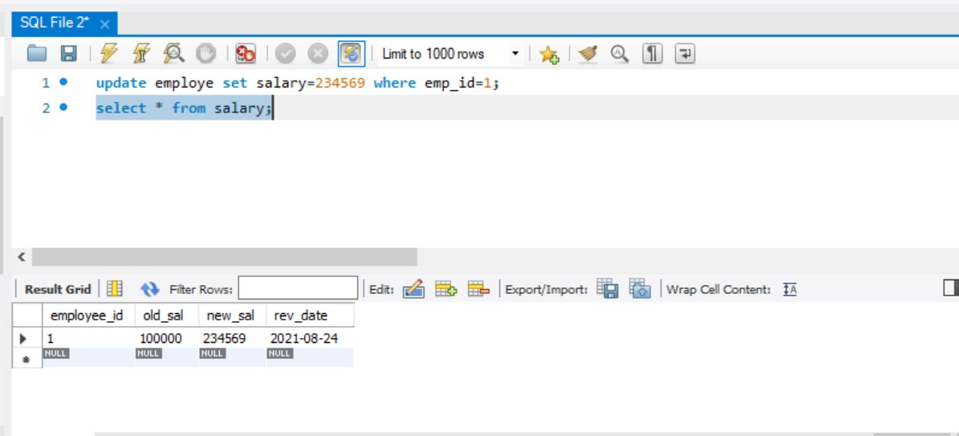

#### AIM

To have familiarize with trigger functions

# Question

Create a Trigger for employe table it will update another table personal_updations while updating values

#### OBJECTIVE

To develop and execute a Trigger for Before and After update/Delete/Insert operations on a table

PROCEDURE

step 1: start

step 2: initialize the trigger.

step 3: On update the trigger has to be executed. step 4: execute the trigger procedure after updation

step 5: carryout the operation on the table to check for trigger execution. step 6: stop

#### PROGRAM

sql>

CREATE TABLE `employe` (

`emp_id` int(11) NOT NULL,

`emp_name` varchar(45) DEFAULT NULL,

`dob` date DEFAULT NULL,

`address` varchar(45) DEFAULT NULL,

`designation` varchar(45) DEFAULT NULL,

`mobile_no` int(11) DEFAULT NULL,

`dept_no` int(11) DEFAULT NULL,

`salary` int(11) DEFAULT NULL, PRIMARY KEY (`emp_id`)

);

Sql>

CREATE TABLE `personal_updations` (

`emp_id` int(11) NOT NULL,

`old_phoneno` int(11) DEFAULT NULL,

`new_phoneno` int(11) DEFAULT NULL,

`rev_date` date DEFAULT NULL, PRIMARY KEY (`emp_id`)

);

Sql>

CREATE DEFINER=`root`@`localhost` TRIGGER

`employe_AFTER_UPDATE_1` AFTER UPDATE ON `employe` FOR EACH ROW BEGIN

if(new.mobile_no != old.mobile_no) then

INSERT INTO personal_updations (emp_id,old_phoneno,new_phoneno,rev_date) values (new.emp_id,new.mobile_no,old.mobile_no,sysdate()); END if;

END

sql>

update employe set mobile_no=34566 where emp_id=4 ; select * from personal_updations;

# OUTPUT

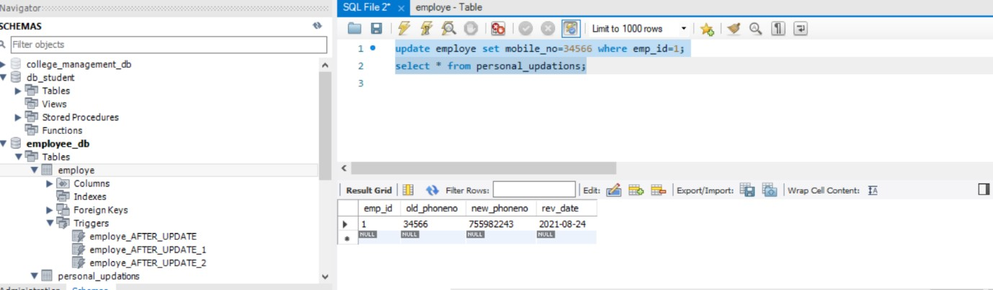

#### AIM

To have familiarize with trigger functions

# Question

Create a Trigger for employe table it will update another table promotions while updating values

#### OBJECTIVE

To develop and execute a Trigger for Before and After update/Delete/Insert operations on a table

#### PROCEDURE

step 1: start

step 2: initialize the trigger.

step 3: On update the trigger has to be executed. step 4: execute the trigger procedure after updation

step 5: carryout the operation on the table to check for trigger execution. step 6: stop

#### PROGRAM

sql>

CREATE TABLE `employe` (

`emp_id` int(11) NOT NULL,

`emp_name` varchar(45) DEFAULT NULL,

`dob` date DEFAULT NULL,

`address` varchar(45) DEFAULT NULL,

`designation` varchar(45) DEFAULT NULL,

`mobile_no` int(11) DEFAULT NULL,

`dept_no` int(11) DEFAULT NULL,

`salary` int(11) DEFAULT NULL, PRIMARY KEY (`emp_id`)

);

Sql>

CREATE TABLE `promotions` (

`emp_id` int(11) NOT NULL,

`old_designation` varchar(11) DEFAULT NULL,

`new_designation` varchar(11) DEFAULT NULL,

`rev_date` date DEFAULT NULL, PRIMARY KEY (`emp_id`)

);

sql>

CREATE DEFINER=`root`@`localhost` TRIGGER

`employe_AFTER_UPDATE_2` AFTER UPDATE ON `employe` FOR EACH ROW BEGIN

if(new.designation != old.designation) then

INSERT INTO promotions (emp_id,old_designation,new_designation,rev_date) values (new.emp_id,new.designation,old.designation,sysdate());

END if; END

sql>

update employe set designation='clk' where emp_id=1; select * from promotions;

# OUTPUT

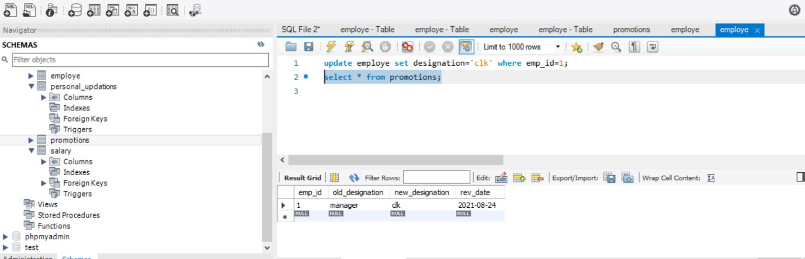

**EXPERIMENT NO. 9**

## How to Download & Install MongoDB on Windows

The installers for MongoDB are available in both the 32-bit and 64-bit format. The 32-bit installers are good for development and test environments. But for production environments you should use the 64-bit installers. Otherwise, you can be limited to the amount of data that can be stored within MongoDB.

## Download & Install MongoDB on Windows

The following steps can be used to install MongoDB on Windows 10:

**Step 1:**

After downloading MongoDB, open the msi file and click next.

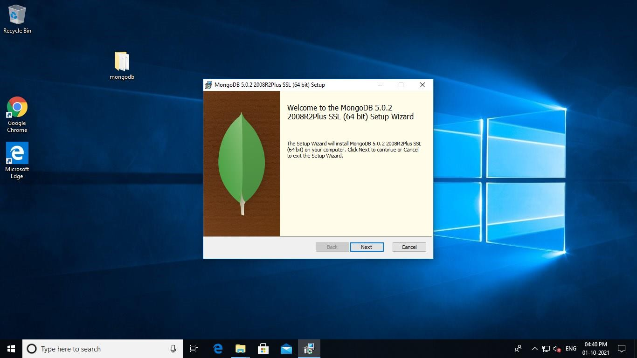

**Step 2:**

1. Accept the End-User License Agreement
2. Click Next

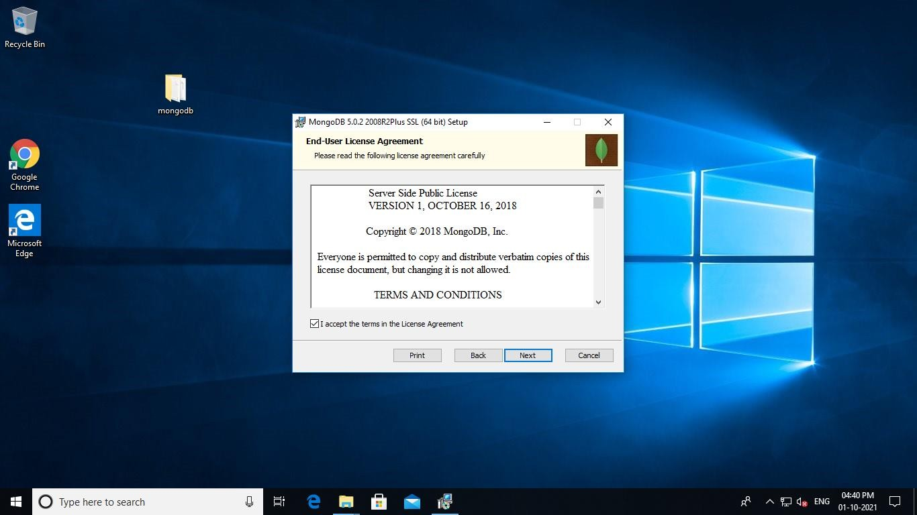

**Step 3:**

### Click on the "complete" button to install all of the components. The custom option can be used to install selective components or if you want to change the location of the installation.

1. Select “Run service as Network Service user”. Make a note of the data directory, we’ll need this later.
2. Click Next

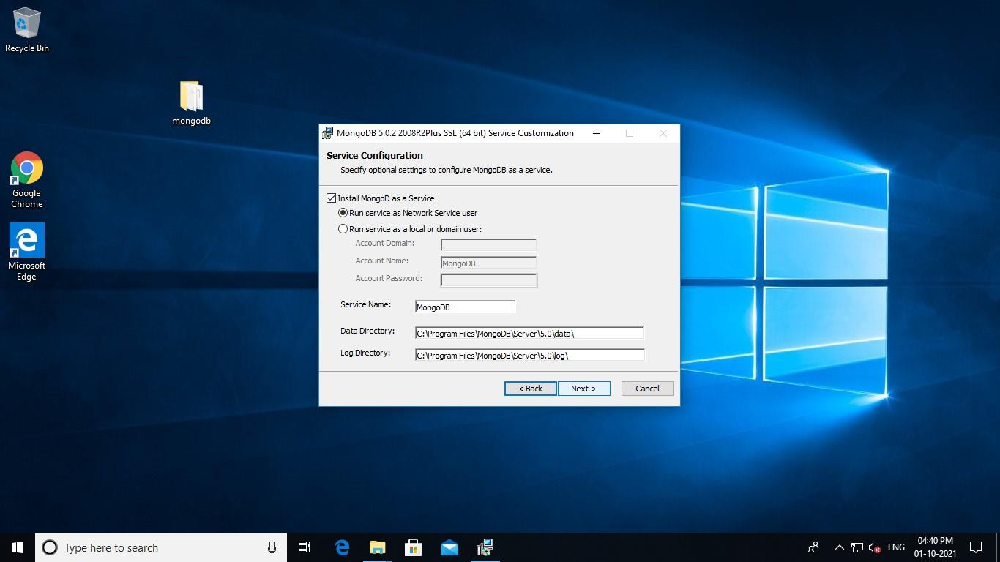

**Step 4:**

Click on the Install button to start the installation. Installation begins. Click next once completed. Click on the Finish button to complete the installation.

